NEWS FROM US JUSTICE DEPARTMENT
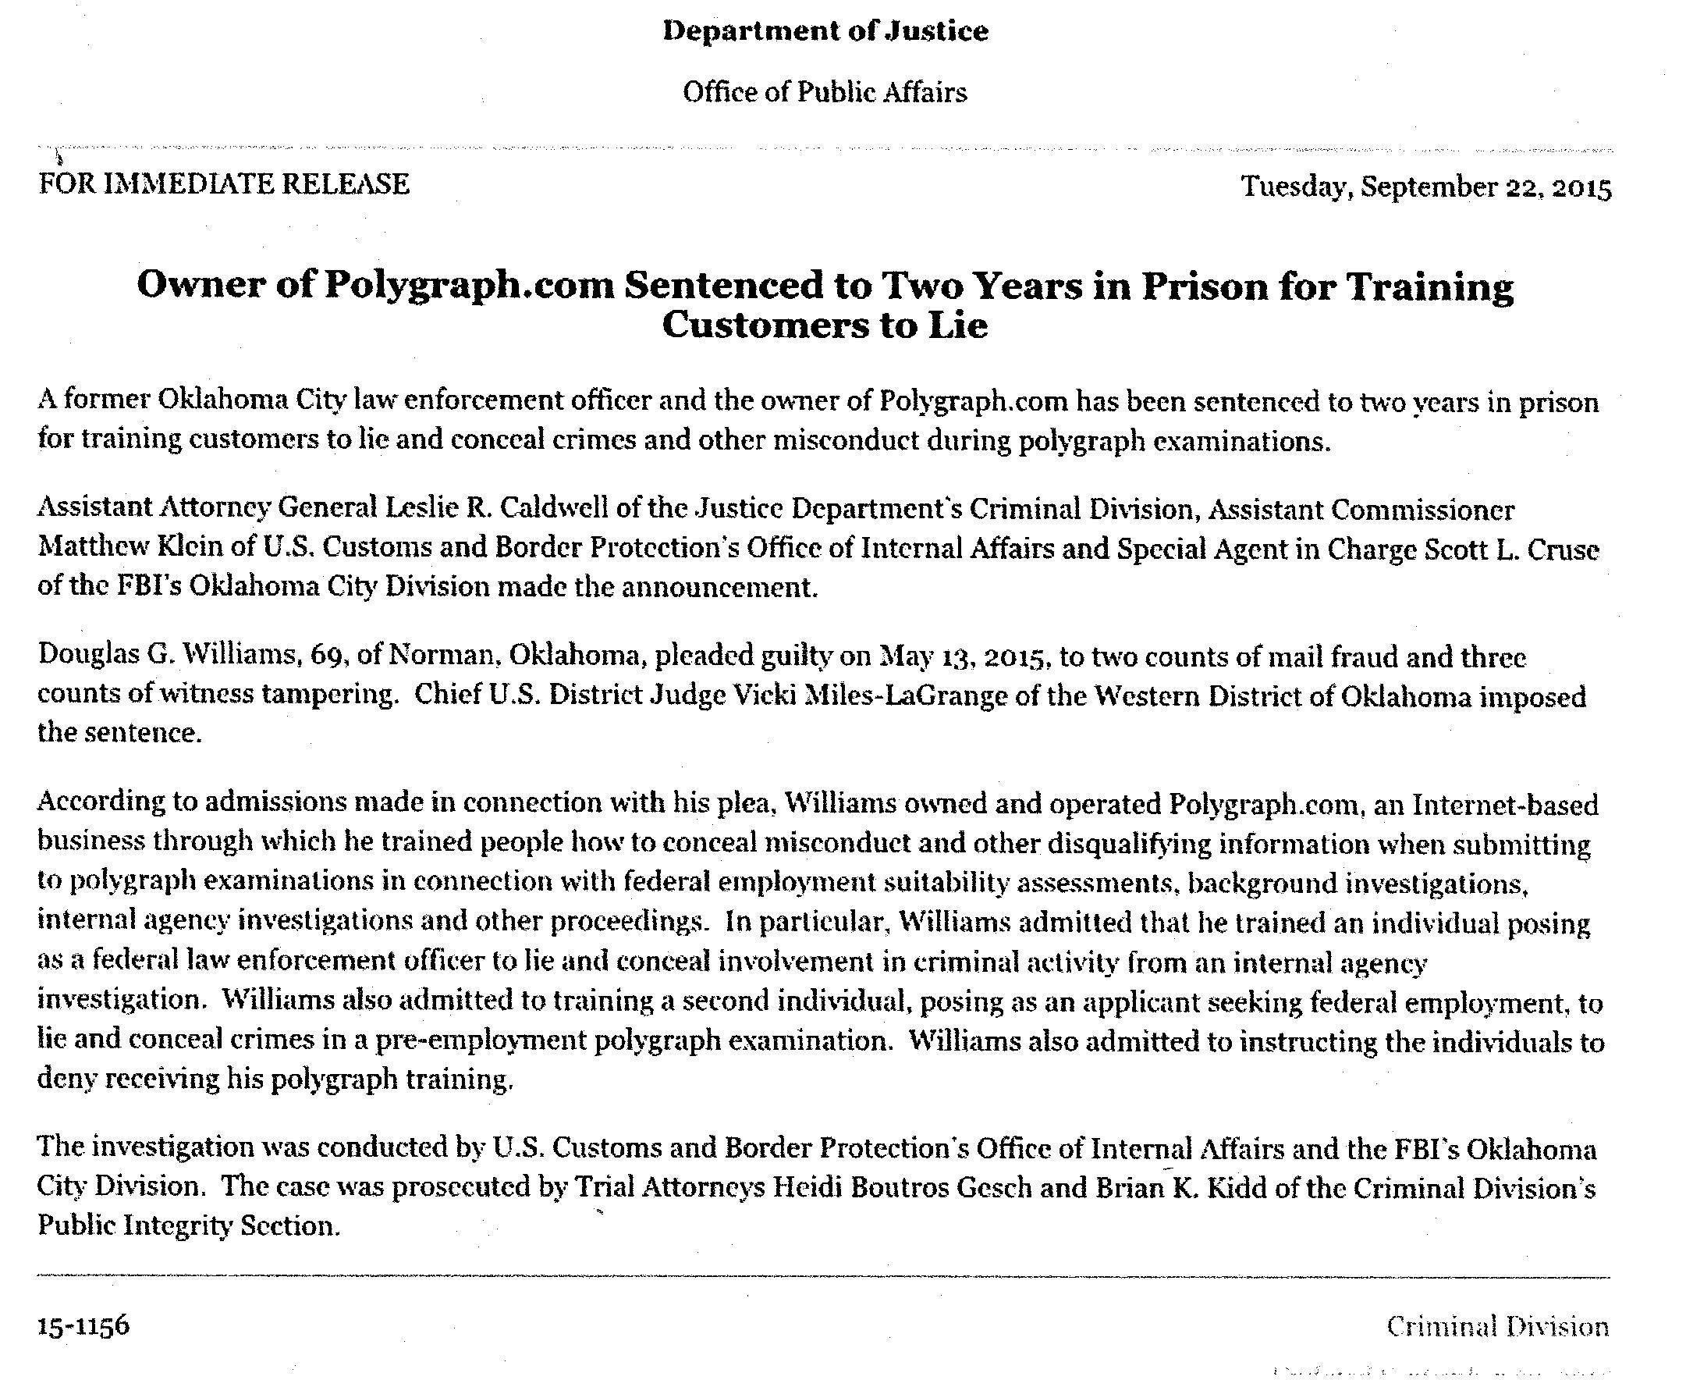
Source: Fellow FPA Member Herb Metzgar
Cc: file
/jt
09/22/2015

