FPA 50th ANNIVERSARY PULLOVER SHIRTS
NOW AVAILABLE FOR PRE-ORDERING

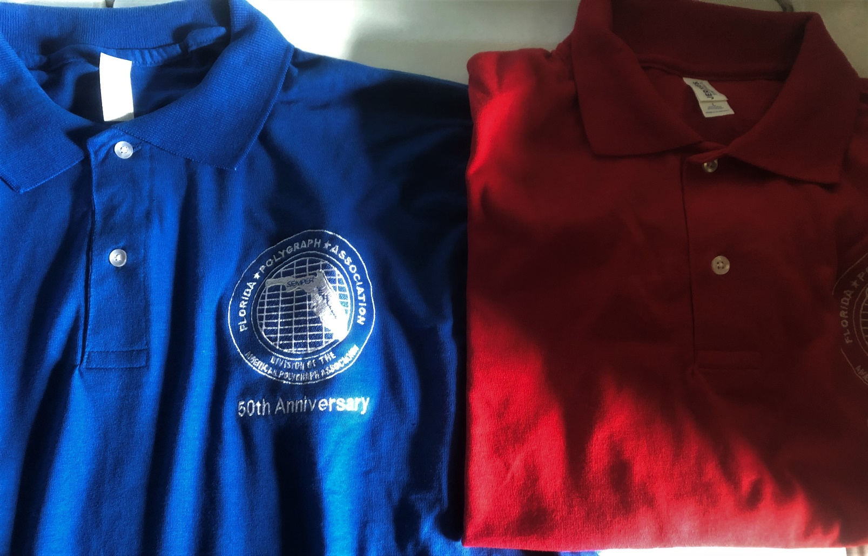
Made by JERZEES, a quality product, 5.6 oz. Cotton Jersey Knit Polo.
Size Options: medium to XXX large
Color Options: royal blue, red, navy and black
LOGO is EMBROIDERED – NEW LOGO WILL BE UTILIZED
COST: $35.00 prepaid per shirt which includes shirt, embroidering and shipping.
$30.00 prepaid and delivered at 50th anniversary seminar
CONTACT AND PAYMENT
John Thorpe, FPA Treasurer
P.O. Box 530279
Debary FL 32753-0279
NOTE: DEADLINE FOR ORDERING IS OCTOBER 01, 2022

Cc: file, newsletter 06/01/2022 /jt

