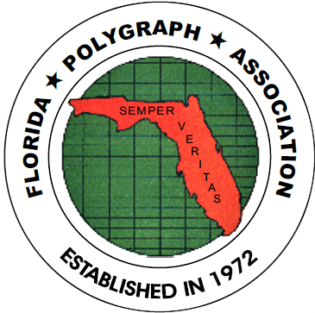
FLORIDA POLYGRAPH ASSOCIATION
www.floridapolygraph.org

POST 50th ANNIVERSARY SEMINAR NEWS

The FPA’s 50th Anniversary Celebration Seminar was held in November, 2022 at the Safety Harbor Resort and Spa, just adjacent to Clearwater, FL. Quest speakers were Jared Rockwood of Utah and our own board member Joseph Waters. Both presented great information needed by all members. Both presentations were up to date and relevant to our profession. We had 55 members in attendance Friday and 50 on Saturday.

Our President, Joseph Pirro, presented a brief history of the association from 1972 to the current year as well as mentioning some important events through the years along with past presidents and members who had previously been honored for outstanding service to the association. It was a nice opening ceremony that also included a guest singer for the National Anthem, presentation of the colors by Pinellas County SO Honor Guard, an opening benediction by FPA Board Member Christopher Conley, Largo PD Bagpiper presentation, and the introduction of the current FPA Board Members.

We were also delighted with a beautiful memorial table, a sit down catered Dinner on Friday night with
Popular dinner music, and later dance music from DJs Carla and Craig Harper. YES, some attendees got the opportunity to dance and listen to good music. Even our president was known to get on the dance floor with his wife and dance. Quite a sight, as they both were “cutting the rug.”

We also need to thank President Joseph Pirro and his wife for the idea of the 50th anniversary cake, its design and for providing the funding. The cake was the talk of the town for Friday and Saturday at the seminar.

Your FPA Board decided to move forward with only one seminar per year as the costs are continually rising and we needed to hold the line on costs. The other major reasoning was the fact that most government agencies are no longer sending members to outside training due to small training budgets. Therefore, the FPA members voted at the Sunday Business Meeting to change the FPA Constitution and By-Laws to reflect on the major change of one-seminar per year. Those revised documents are all loaded in your online newsletter.

Each Certified Polygraphist and Certified PCSOT Examiner will still have the opportunity to keep their certifications by attending the once-a-year seminar as we will extend the seminar one additional day to ensure each attendee gets the required number of classroom hours.

The once-a-year seminar will be held during the weekend just prior to Thanksgiving week at some Florida Central venue. This information is always posted in your online newsletter.
Your 2023 FPA Dues are now payable and due. Please get them in if you have not. There is a generic dues invoice posted in your online newsletter and should have gotten one in the USPS snail mail. Please get those in to your treasurer. The 2023 FPA Dues Invoice posted in the newsletter is edit capable to suit your agency or business needs.

Please go online to your newsletter and read through it as some items will be removed shortly. News is always posted in your online newsletter first before any announcements or mass E-mail outs sent. ALSO, go online and make sure your member profile address and E-mail are current and correct, as your treasurer also stays in touch with the membership via a “Mass E-mail out system” from the web site.

There will be some navigational changes to the web site after the first of the year, so please go to your web site frequently and navigate around in it.

Thank you Vendors for your attendance and assistance also. It was the first time in many years that all our instrument vendors were present at our seminar. Equity Markets Insurance was also present as one of our vendors. Please than Tracey Stewart, Sue Luttrell, Bruce White and Melanie Javens for their attendance and assistance during the seminar as our vendors.

Remember that the FPA Certifications are based on continuing education in the profession and are not for life. Each certification must be renewed by maintaining a certain number of classroom hours. The hour requirements and yearly requirements are all loaded in the FPA Web Site. Our Randall Jones School for Continuing Studies Director, Sandy Dunn, is the keeper of all your training hours and certification training hours and certification renewals. Questions about your certifications should be directed toward her.

FPA Board Member Christopher Conley is also our new Social Media Committee Chair Make sure you take a look at our Facebook and Instagram sites.

Just another reminder for all!! Please get your 2023 FPA Dues in ASAP as December-January is the busy season for your treasurer due to tax filing and accounting and web site updates. Your dues will be delinquent at the end of March and you will be removed from the web site as an active member. If you are not sure if your 2023 FPA Dues are paid or not, please contact your treasurer at: Ltthorpe@iag.net.

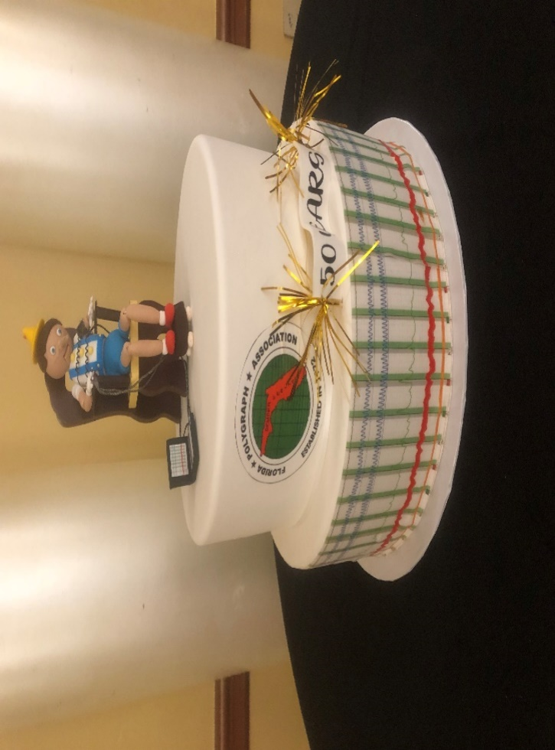
50th Anniversary Cake
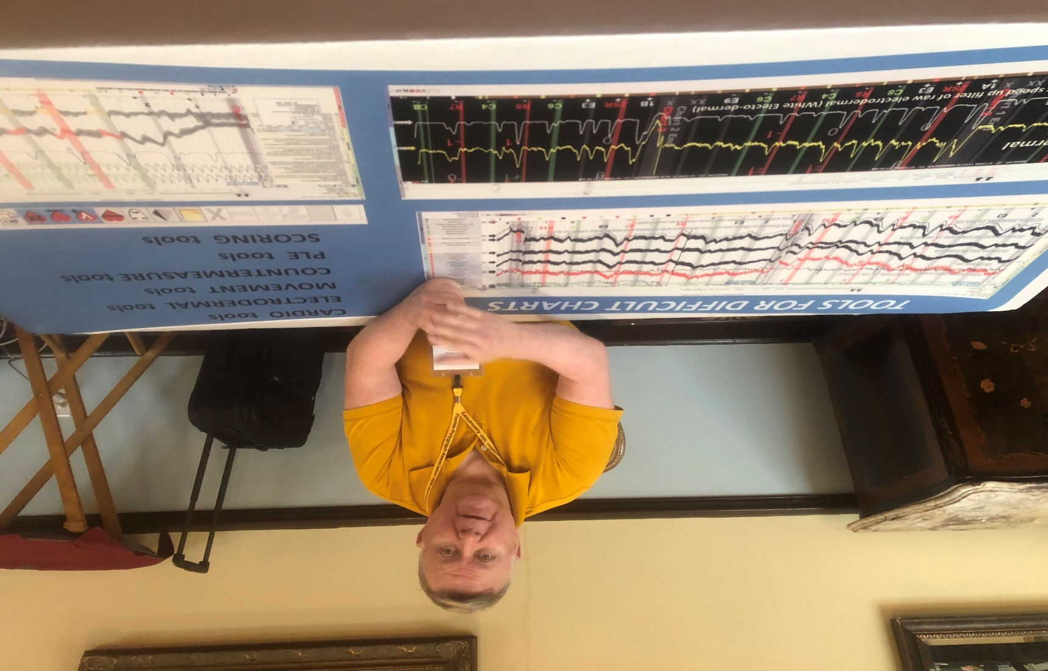
Bruce White, FPA Member and Axciton Vendor
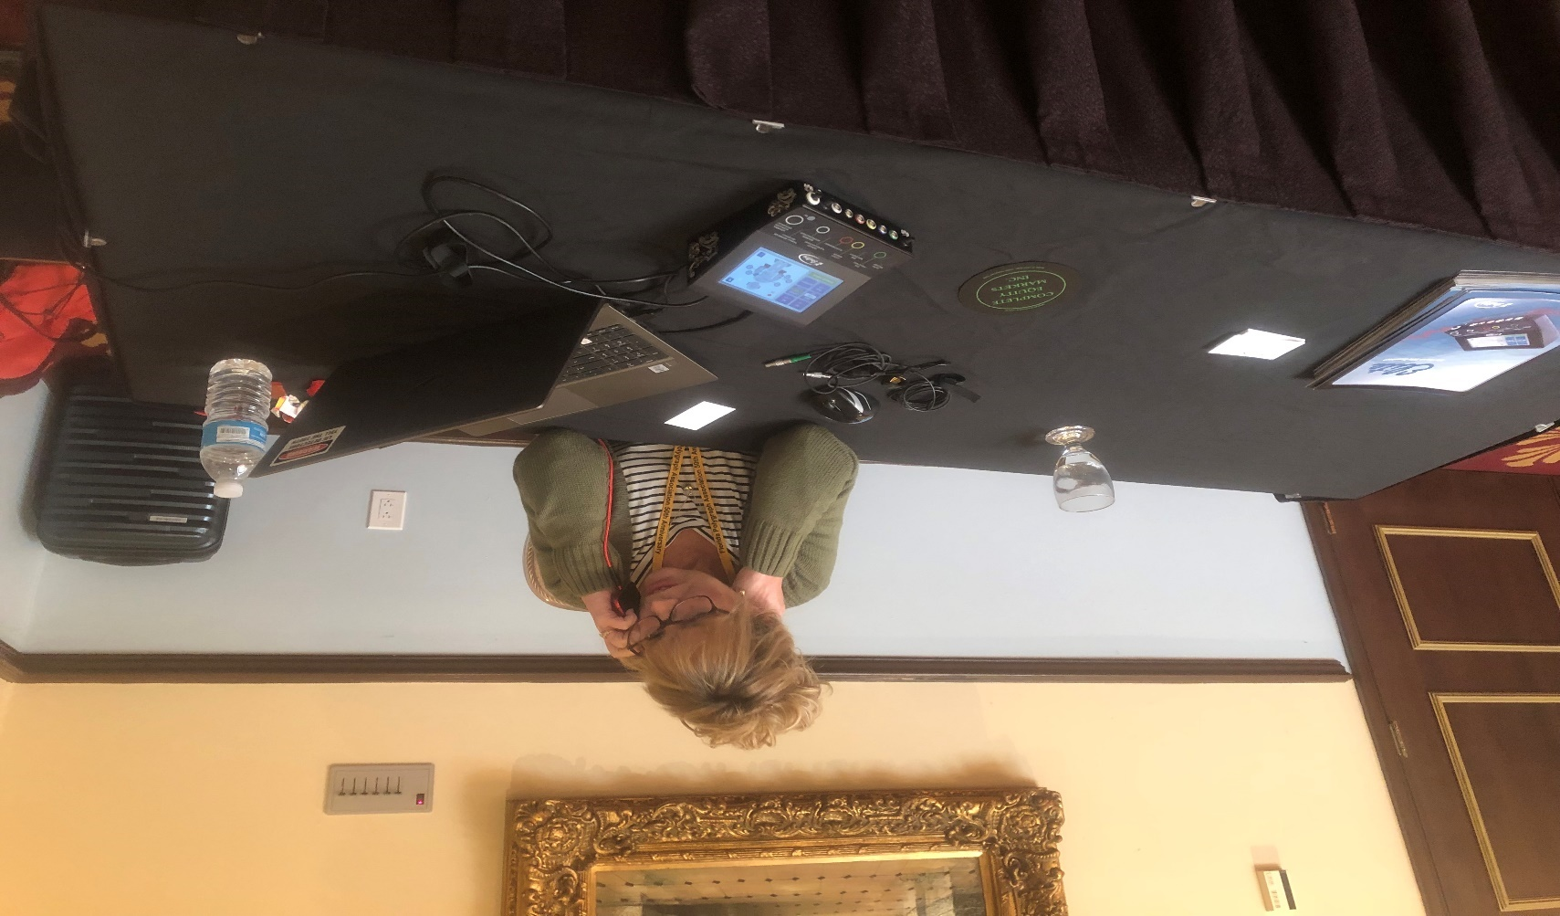
Sue Luttrell, Stoelting Vendor
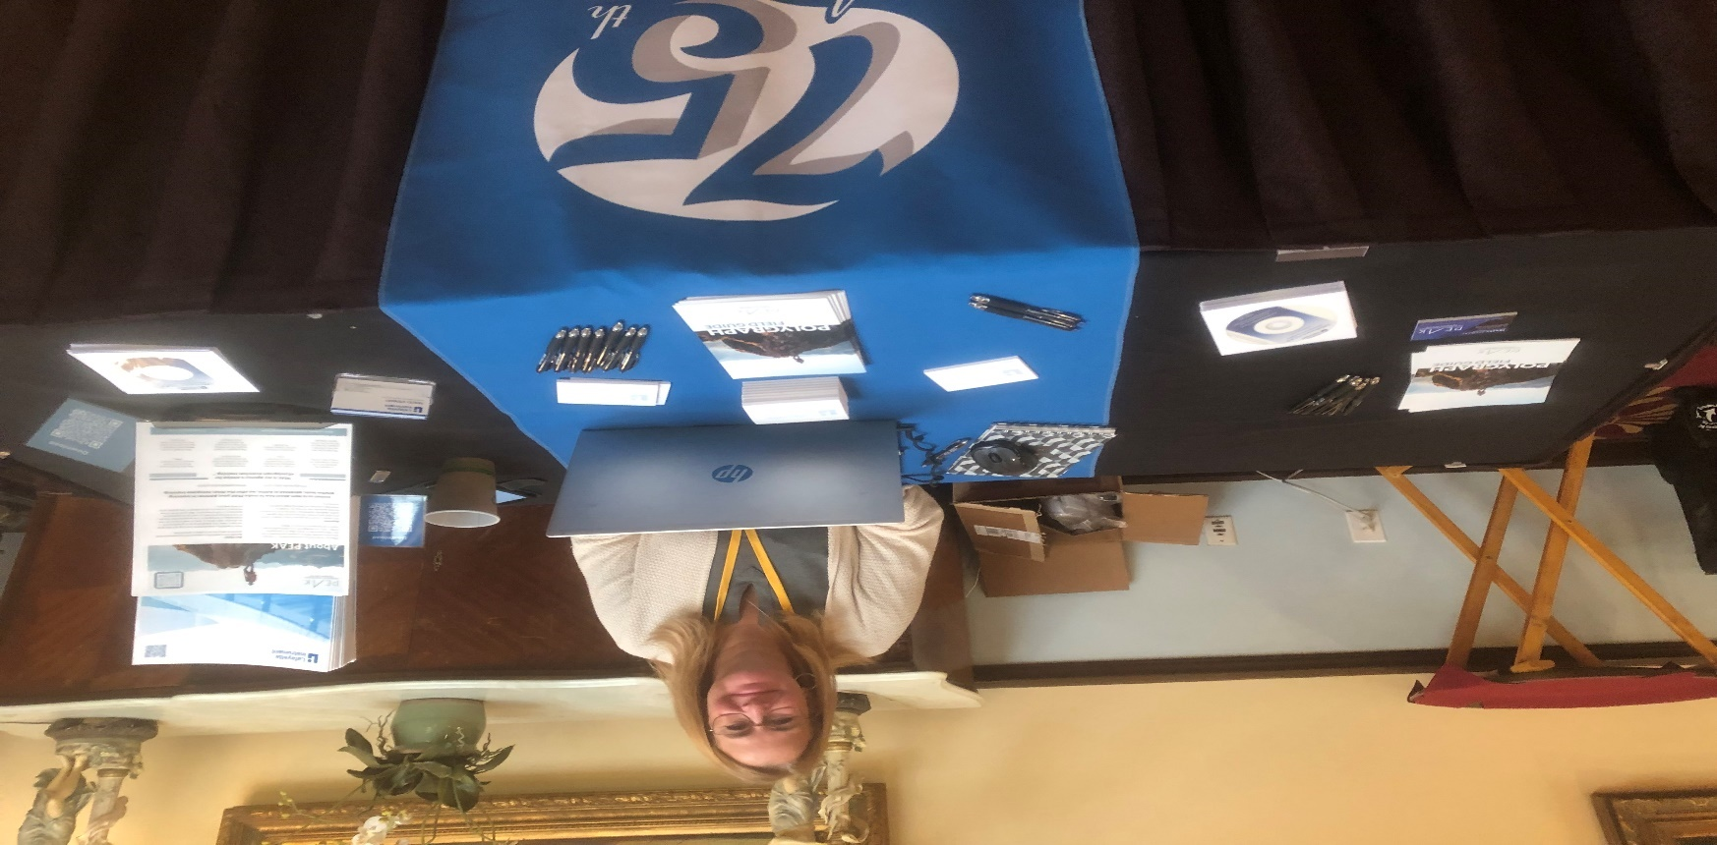
Tracey Stewart, Lafayette Vendor

