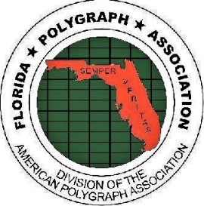
FLORIDA POLYGRAPH ASSOCIATION

Here is a recap of membership applications approved by the FPA Board since March, 2021

GINNY FOXX DAMEIAN JOHNSON
Full, Private class. Full, Private class.
Member since March,2021 Member since June, 2021
Poly. School: PEAK, 11/20 Poly. School: New England PI,04/20
Phone: (305)446-3433 Phone: (954)793-8693
E-mail: skyy@comcast.net E-mail: dameian.johnson42@gmail.com

CHRISTOPHER MAKI MYRON PIGGOTT
North Port P.D. Alachua S.O.
Full, L.E. class. Full, L.E. class.
Member since: March,2021 Member since: March, 2021
Poly. School: PEAK, 11/16 Poly. School: PEAK, 11/20
Phone: (941)628-7833 Phone: (352)367-4028
E-mail: cmaki@northportpd.com E-mail: mpiggott@alachuasheriff.org

NOREEN POLLOCK KEIR REID
Full, Private class. Full, Private class.
Member since: June, 2021 Member since: June, 2021
Poly. School: PEAK, 04/21 Poly. School: Inter.Academy,05/21
Phone: (941)525-2120 Phone: (954)771-6900
E-mail: pollockpolygraph@gmail.com E-mail: Kreid1223@gmail.com

DANIIL SMOLIK KISHIA VEIGEL
Full, Private class. North Port P.D.
Member since: June,2021 Full, L.E. class.
Poly. School: Inter.Academy,05/21 Member since: March, 2021
Phone: (386)529-4471 Poly. School: PEAK, 11/16
E-mail: smolik.polygraph@gmail.com Phone: (941)429-7335
E-mail: kveigel@northportpd.com

PLEASE JOIN WITH THE FPA BOARD IN WELCOMING THESE NEW MEMBERS TO THE F.P.A.

ALL MEMBERS ARE ASKED TO DOWNLOAD THIS DOCUMENT AND SAVE IT AS A NEW MEMBERSHIP
DIRECTORY WILL NOT BE PRINTED IN THE NEAR FUTURE.

Cc: file, Newsletter, archives 06/28/2021 /jt

