Dr Richard Poe and Nancy Poe receiving the D.R. Jones Award from FPA President & the FPA Board at the 2017 June FPA Training Seminar.
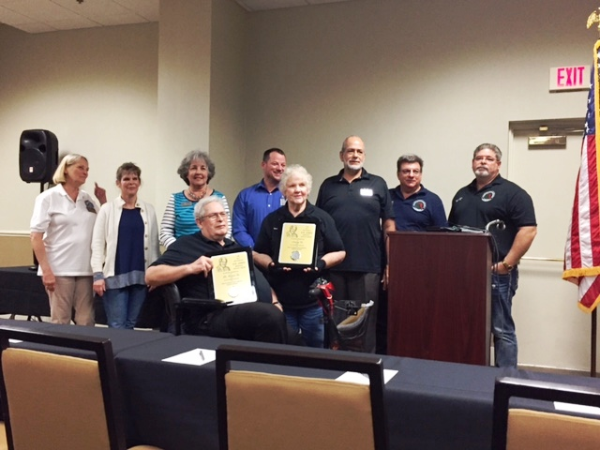
Nancy & Dr Richard Poe receiving the D.R. Jones Award from the FPA President and FPA Board.

From left to right: Peggy Hallock-Kraker, Beth Baucom, Sandra Streator, Ben Blalock, Jorge Fernandez, Joseph Pirro and Dale Young.

