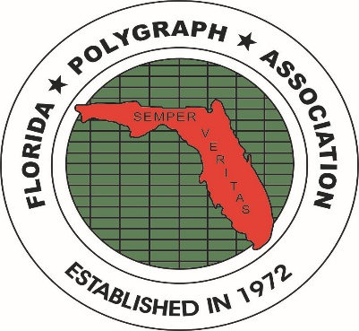
FLORIDA POLYGRAPH ASSOCIATION
www.floridapolygraph.org

APPLICATIONS APPROVED FOR MEMBERSHIP AT THE AUGUST 2023 FPA BOARD MEETING

The following applicants were approved for membership in the FPA by the FPA Board during the August, 2023 board meeting:

GUTIERRIZ, Yusnier MAUL, Kevin
6625 Miami Lakes Dr P.O. Box 336844
3rd Floor, Suite # 338 Greeley, CO 80633
Miami Lakes FL 33014 Phone#: (970) 498-5154
Phone#: (305) 733-9456 Employer: Larimer County S.O.
Employer: Justice Polygraph Services Poly. School: TX DPS,06/08
Poly. School: PEAK, 03/2023 Membership: Full, L.E.
Membership: Full, Private, 08/2023 E-mail: kdmaul@msn.com
E-mail: examiner@justicepolygraphservices.com MembershipApproved:08/2023 Membership Approved: August, 2023

Please join with the FPA Board in welcoming these new members to the FPA.

Cc: file, newsletter, archives 08/07/2023 /jt

