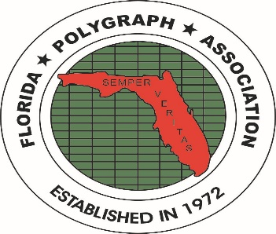

APPLICANTS APPROVED FOR MEMBERSHIP AT THE MAY 2023 BOARD MEETING

PERL, Michael YOUNG, Daninah
2740 Cypress Trace Circle,#2715 782 N. LeJeune Road. Suite 428
Naples, FL 34119 Miami, FL 33126
Phone: (239)331-5517 Phone: (305)446-3433
Employer: TBD Employer: Jurney & Associates
Polygraph School: PEAK, 03/23 Polygraph School: IAP, 11/22
Membership: Full, Private 05/23 Membership: Full, Private 05/23
E-mail: bacfu@yahoo.com E-mail: daninahyoung@icloud.com
Approved: May, 2023 Approved: May, 2023

PLEASE join with the FPA Board in welcoming these two new members to the FPA!

Cc: file, newsletter, archives 05/2023 /jt

