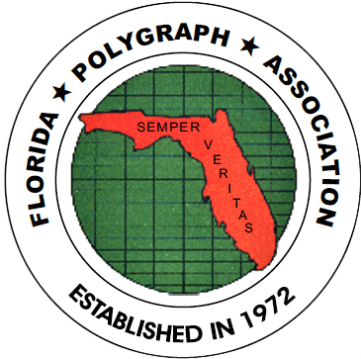

APPLICANTS APPROVED FOR MEMBERSHIP AT FEBRUARY 2023 BOARD MEETING

Palmer, Janet Seaman, Ashley
121 SW Port St. Lucie Blvd. 121 SW Port ST. Lucie Blvd.
Port St. Lucie, FL 34984 Port St. Lucie, FL 34984
Phone: (772) 879-3397 Phone: (772) 871-7304
Employer: Port St. Lucie PD Employer: Port St. Lucie PD
Polygraph School: PEAK, 03/22 Polygraph School: PEAK, 03/22
Membership: Full,L.E., 02/23 Membership: Full, L.E., 02/23
E-mail: jpalmer@cityofpsl.com E-mail: aseaman@cityofpsl.com
Approved: February, 2023 Approved: February, 2023

Payne, Terrence Lewis-Ximinies, Alkie
100 NW 2nd Ave 9500 Pines Blvd
Boca Raton, FL 33432 Pembroke Pines, FL 33024
Phone: (561) 620-6221 Phone: (954) 743-1640
Employer: Boca Raton PD Employer: Pembroke Pines PD
Polygraph School: IAP, 12/21 Polygraph School: IAP.11/22
Membership: Full, L.E.,02/23 Membership: Full,L.E., 02/23
E-mail: tpayne@myboca.us E-mail: aximinies@ppines.com
Approved: February, 2023 Approved: February, 2023

Cc: file, archives 02/2023 /jt

