ACTIVITIES AT THE 50th ANNIVERSARY SEMINAR

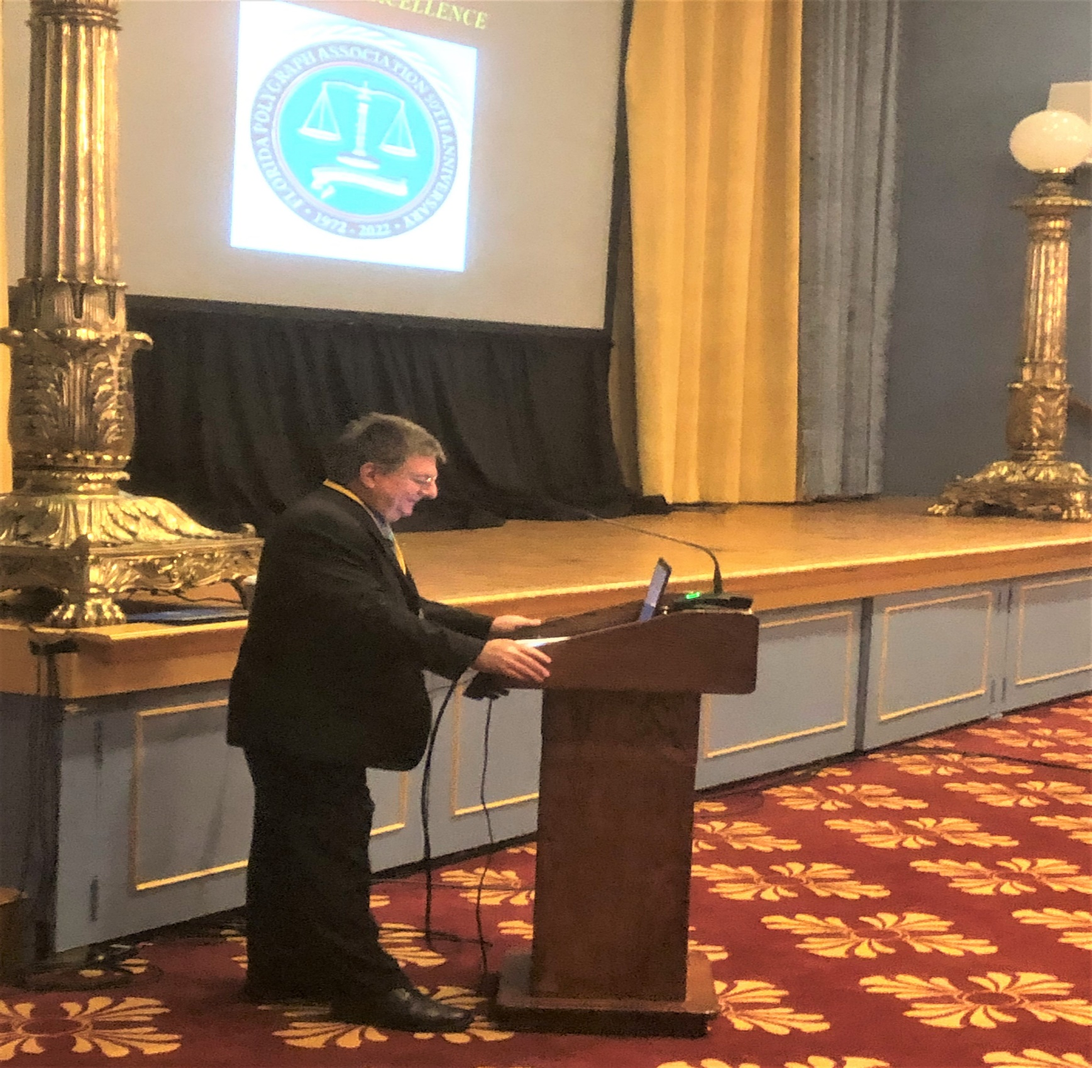
FPA PRESIDENT JOSEPH PIRRO OPENING SPEECH

This opening ceremony speech included the introduction of the honor guard, the singer of the National Anthem, the opening prayer by FPA Board Member Chris Conley, a brief historical outline of the FPA including the past presidents, acknowledgement of the past presidents in attendance, the introduction of the Largo Police Department Bag Piper as a remembrance for all those members who have gone before us, and an introduction of all current board members as well as the guest speakers.

