ACTIVITIES AT THE 50th ANNIVERSARY SEMINAR
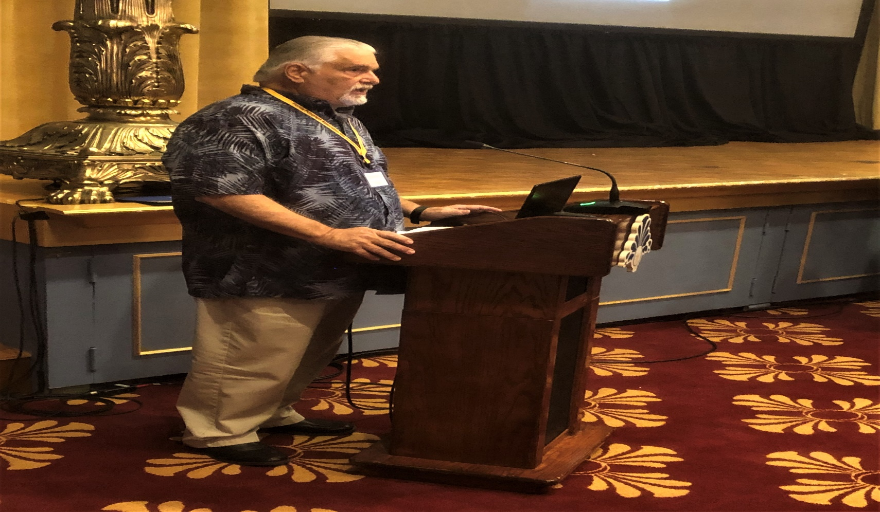
Singing of the National Anthem by David Sparano

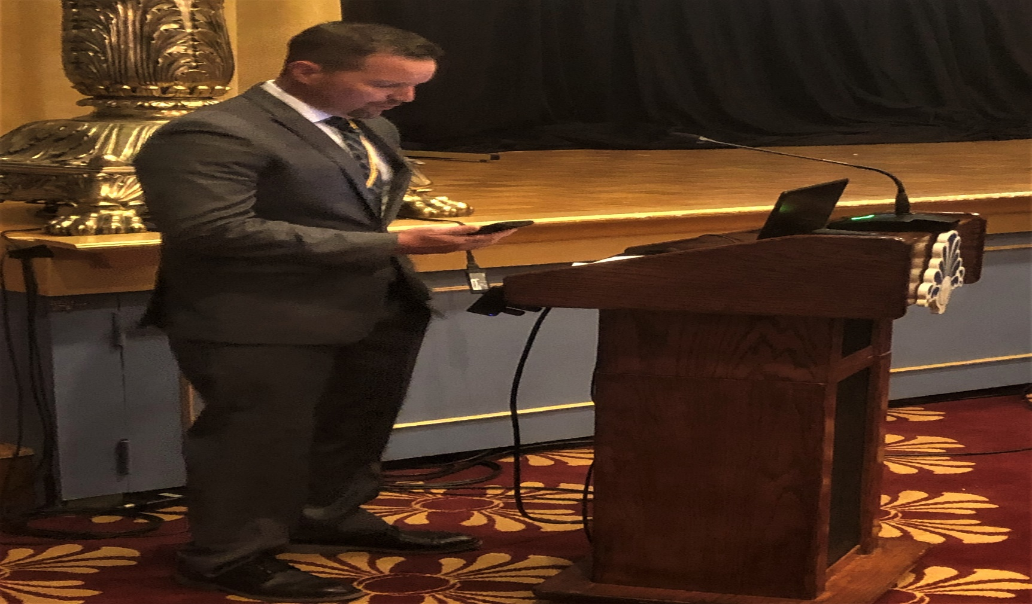
Opening Ceremony Prayer by FPA Board Member Chris Conley

