ACTIVITIES AT THE 50TH ANNIVERSARY SEMINAR

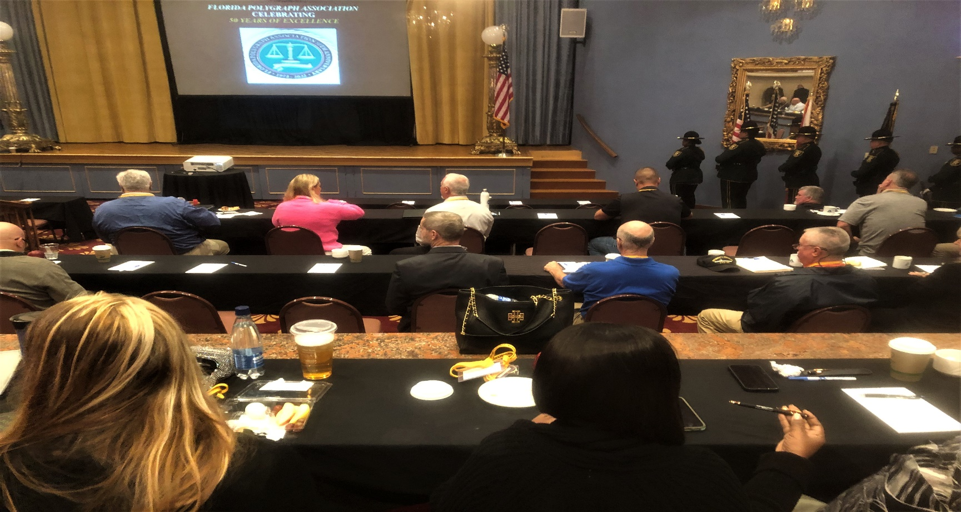
Pinellas County Sheriff’s Office Honor Guard staging
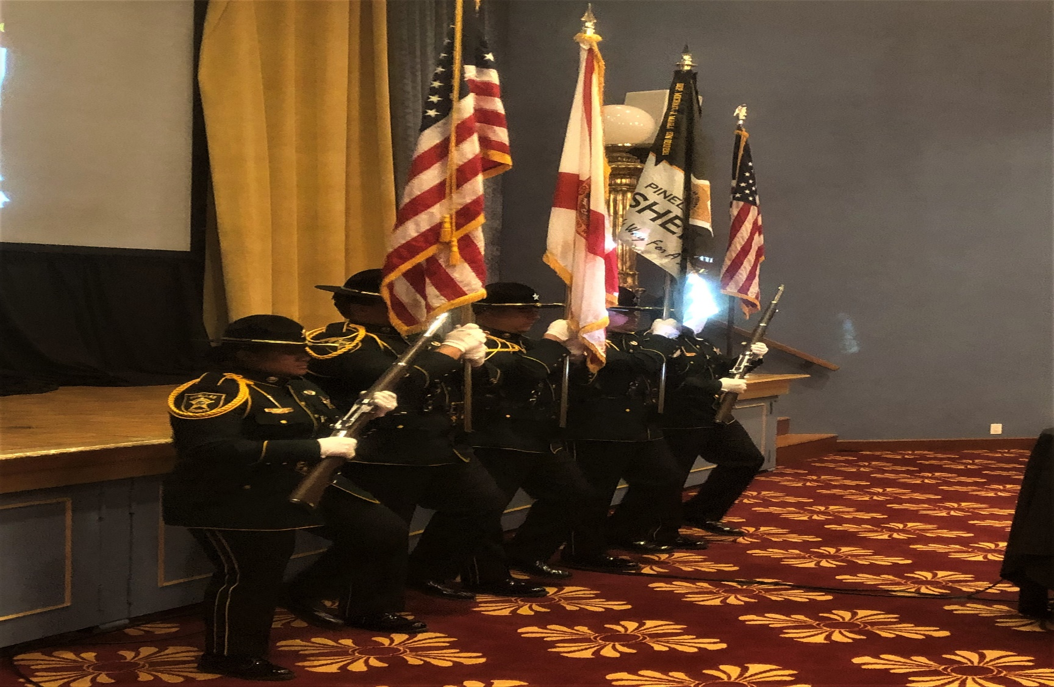
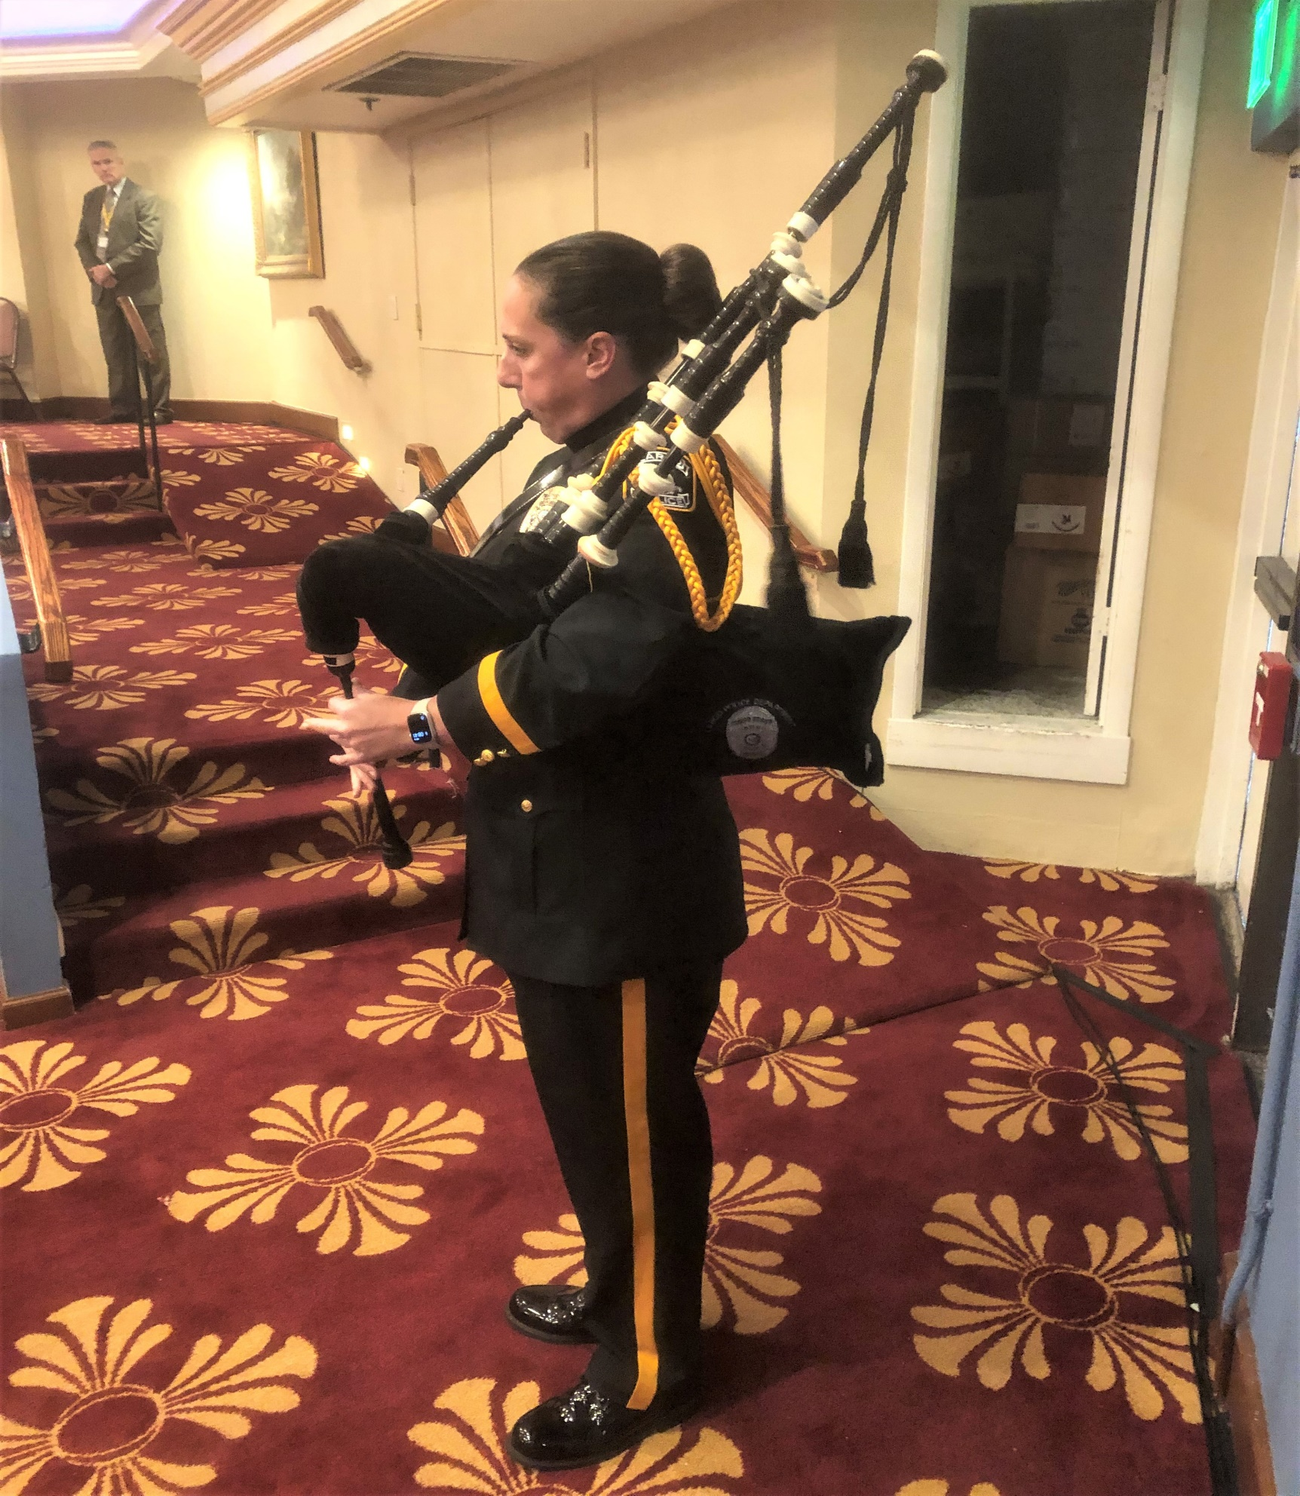
Largo PS Bagpiper performing during the opening ceremonies.

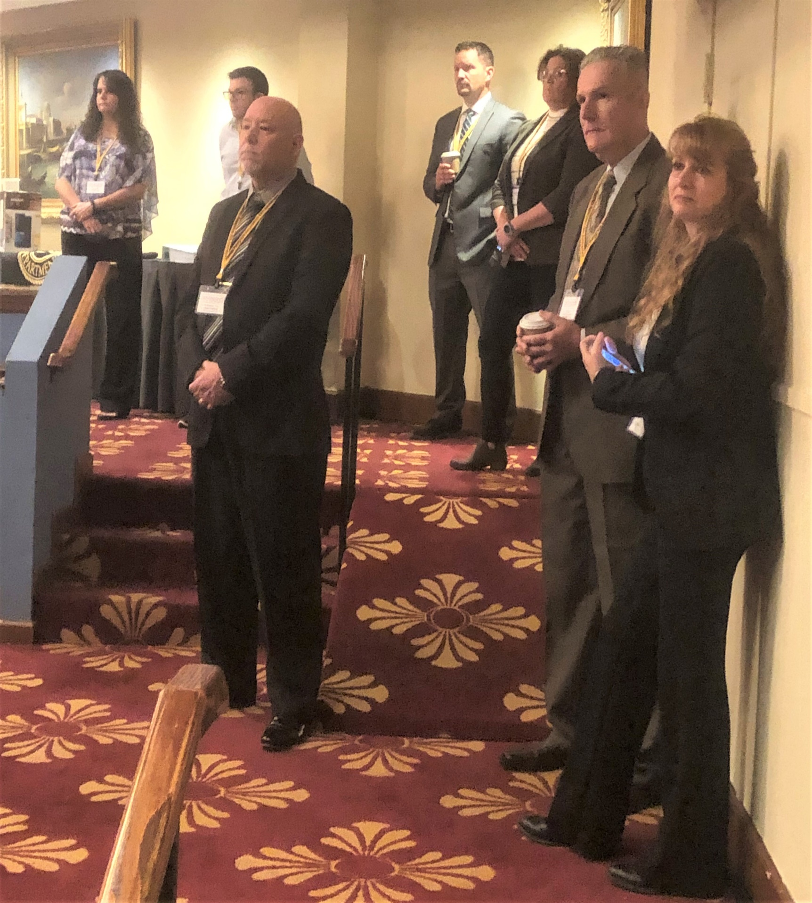
SEE some new faces??
The current FPA Board (some of them)waiting to be introduced to the attendees.

