ACTIVITIES AT THE 50TH ANNIVERSARY SEMINAR

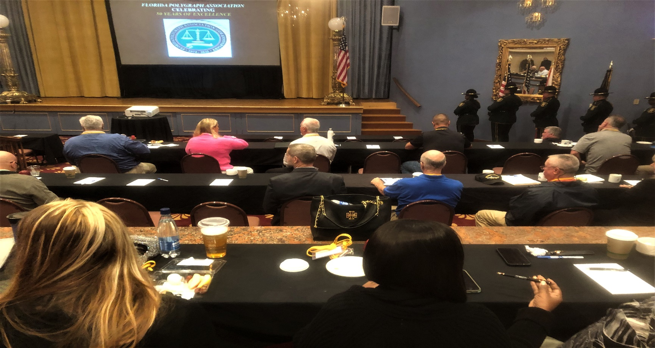
Pinellas County Sheriff’s Office Honor Guard staging
